**iTag Interface Software Mac**

v 1.0 21 Feb 2017

Run iTag.app (on Mac)

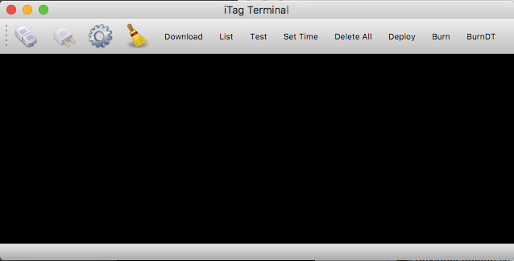

1. Plug in USB cable into iTag

2. Click on Settings (Gear) icon, and select item that is named something like cu.usbmodemxxxx

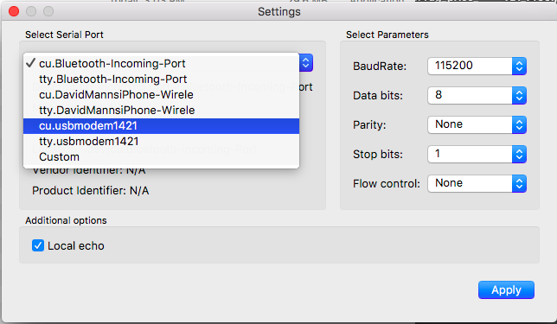

It should show Arduino Zero under Description.

Do not change any other setting.

Click Apply

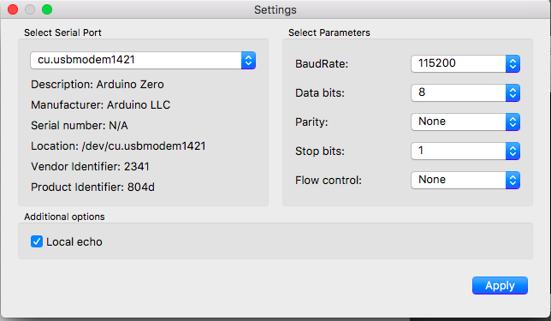

3. Click Connect to Serial Port icon on left

4. The tag is configured by click on action names on the menu bar

**Download:** Downloads all files to directory with ID of tag

**List**: List files on card

**Test**: Test sensors and show output to screen

**Set Time**: Set time to computer time

**Delete All**: Delete all files on card (should be done prior to a new deployment). Must press twice to delete files.

**Deploy**: Start the tag recording.

**Burn**: Set burn to trigger after a desired number of minutes

**BurnDT**: Set burn to trigger at a specific datetime given in UTC following format: YYMMDDHHMMSS

**List**

First line: iTag serial number

Following lines: filename and number of bytes

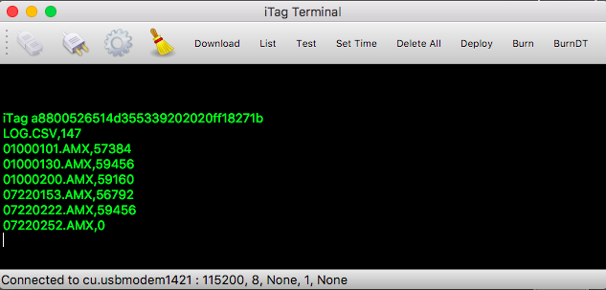

**Test**

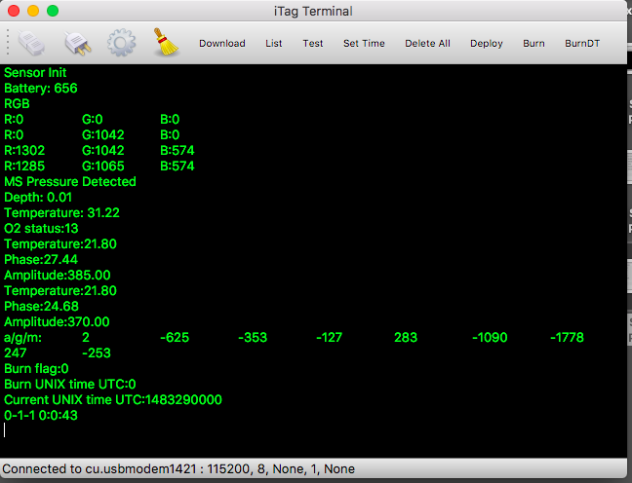

**Typical Scenario**

**Starting Tag**

1. Press Deploy to start recording. The sensor test will show as well as whether there is a burn event configured and the current date and time on the tag.
2. Disconnect from USB. Green LED should flash for 1 minute and then go out.

**Stopping Tag**

1. Use magnet to temporarily switch tag off by moving magnet to within 1 cm of magnetic switch. Green LED will illuminate constantly if there is any battery power left.
2. Connect to USB and iTag configuration software.
3. Download data

**Troubleshooting**

**Can’t connect**: Let tag charge for a few minutes. Switch off with magnet momentarily. Try to connect again.